**Audience Heatmaps - Entertainment Sector**

Pooja Joshi & E.Code [E25007]

# Overview :

# The objective of this report is to summarize the progress made in the task of creating audience heatmaps for the entertainment sector. This task aims to analyze audience engagement and attendance patterns based on various factors, including time of day, day of the week, and sentiment analysis.

# Objective:

· **To visualize audience attendance patterns through heatmaps.**

· **To analyze the impact of time and sentiment on audience engagement.**

· **To provide insights that can guide content release strategies.**

# Assigned Task(s) :

· **Create audience heatmaps based on attendance data.**

· **Perform sentiment analysis on audience feedback.**

· **Visualize the results using appropriate charts and graphics.**

· **Utilize SHAP values for model interpretability.**

# Task Details :

· **Task 1: Audience Heatmap Creation**

* **Status:** In Progress
* **Details:** Data has been gathered and preprocessed to include time, day of the week, and sentiment scores. Initial visualizations have been created to represent attendance patterns.

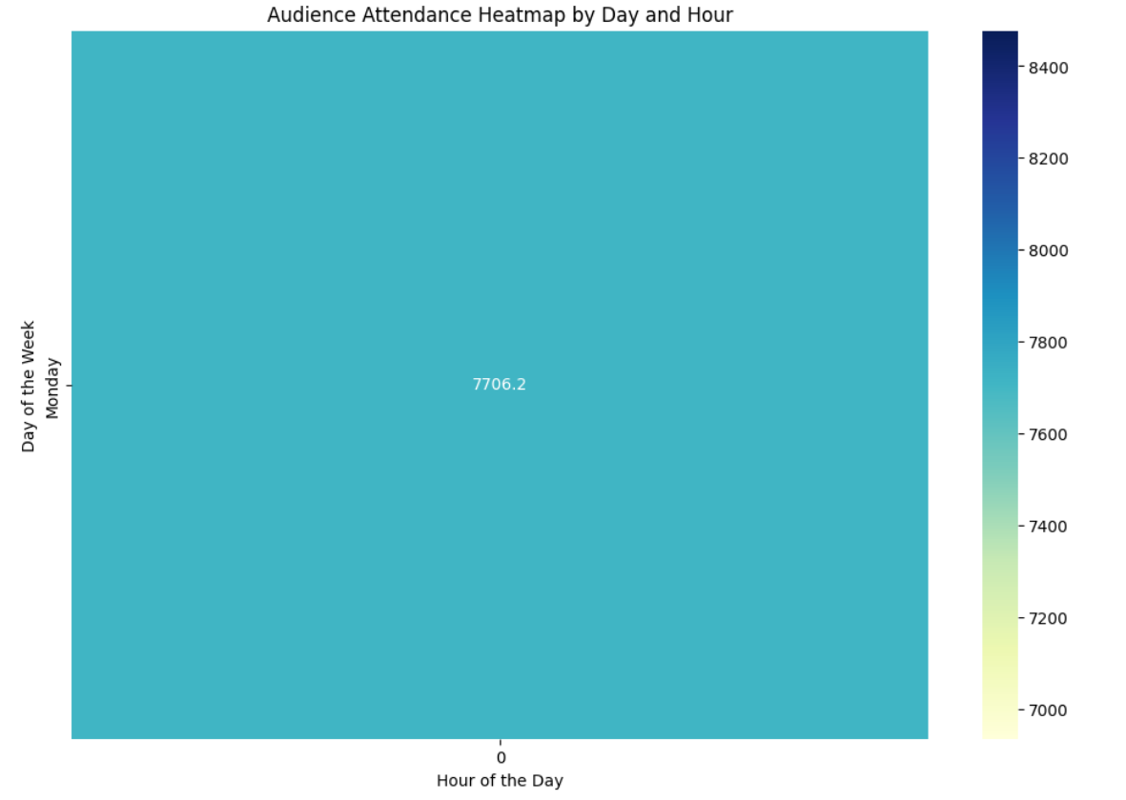

· **Task 2: Sentiment Analysis**

* **Status:** Completed
* **Details:** Sentiment scores were extracted from audience feedback, allowing for correlation analysis with attendance data.

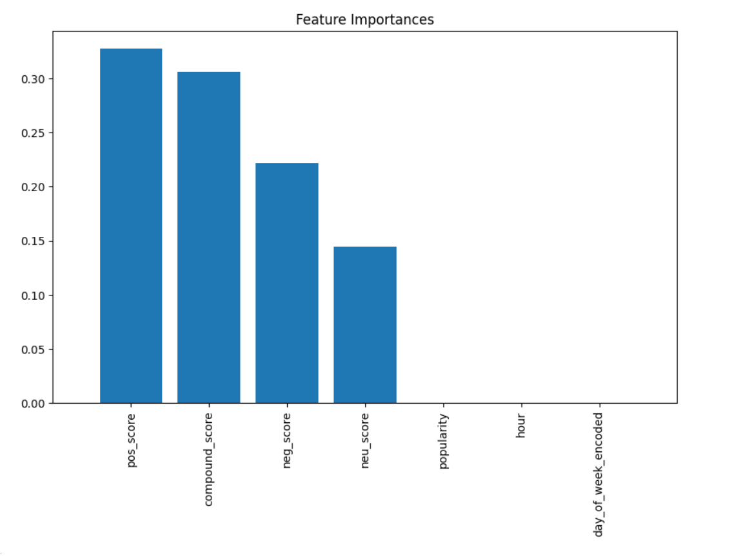

· **Task 3: SHAP Analysis for Model Interpretability**

* **Status:** In Progress
* **Details:** Utilized SHAP values to interpret the model's predictions and understand the impact of different features on attendance predictions. Visualizations of SHAP values are being prepared.

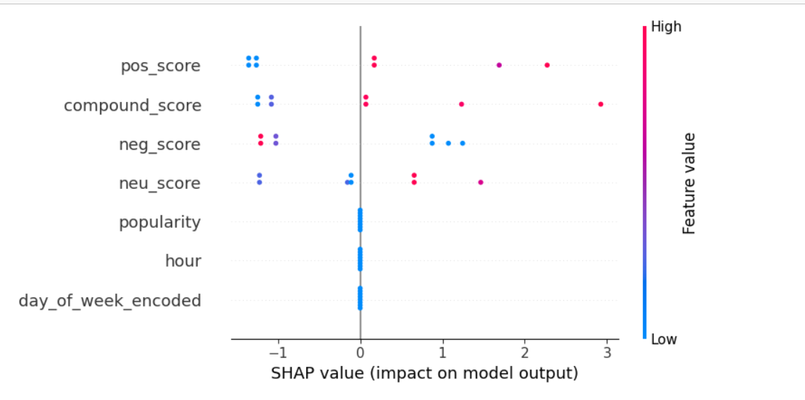

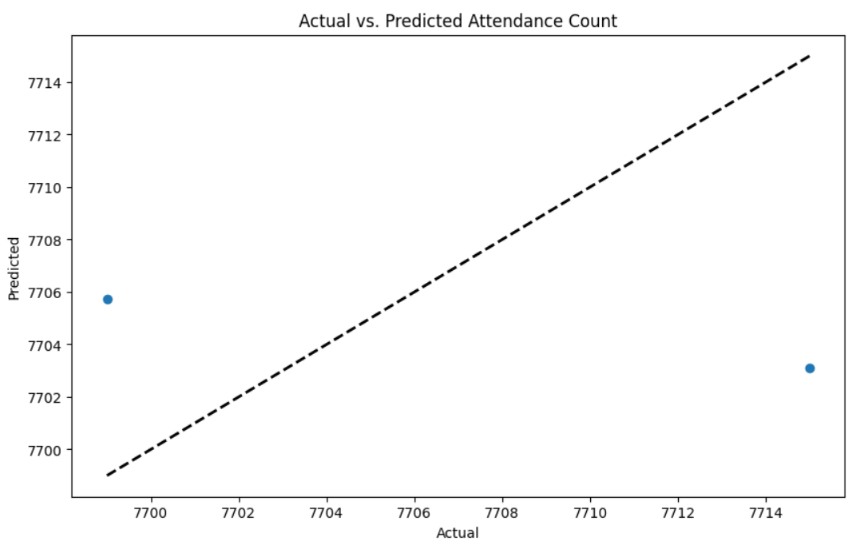

**Progress :**

· **Accomplishments:**

* Successfully created initial audience heatmaps.
* Completed sentiment analysis, providing insights into audience mood.
* Began integrating SHAP values for a deeper understanding of model behavior.

· **Metrics:**

* **Attendance Data:** Total audience count reached 7715.
* **Sentiment Scores:** Average sentiment score was calculated, with a breakdown of positive, neutral, and negative sentiments.

# Challenges and Solutions :

· **Challenges Faced:**

* Difficulty in cleaning sentiment data due to its complex format.
* Initial models did not provide clear insights into audience behavior.

· **Solutions Implemented:**

* Used Python libraries to parse and extract relevant sentiment metrics effectively.
* Adjusted the model based on initial findings to better capture audience engagement.
* Implemented SHAP for clearer interpretability of model predictions.

**Next Steps :**

· **Upcoming Tasks:**

* Finalize audience heatmaps and present them to stakeholders.
* Complete SHAP visualizations and incorporate findings into the final report.

· **Goals:**

* Aim to finalize all visualizations by the end of the week.
* Prepare a comprehensive presentation of findings for the next team meeting.

# Conclusion :

### Summary: The task of creating audience heatmaps and conducting sentiment analysis is progressing well. The integration of SHAP values will enhance our understanding of the factors driving audience engagement.

# **Acknowledgments**: Thank the audience for their time and attention.